**CUTRIC BEB Visualization Modeling Prototype**

**(Case study of Burlington)**

OCAD University Visual Analytics Lab

Sara Diamond, Jeremy Bowes, Mona Ghafouri-Azar, Grace Yuan

# Introduction

The *CUTRIC Transit Fleet Electrification Analysis and the Burlington* prototype is a dynamic HTML dashboard visualization environment that supports many of the analytics that CUTRIC undertook and even extends those functionalities. It provides a GIS map (Cartographic) interface and related graphs/charts. As a prototype it utilizes data from city of Burlington Transit as a use case to develop and test the prototype, however, the prototype should serve as a template that can be applied to any other Canadian cities.

Based on CUTRIC’s request, all the tools employed are open source and free to use. We decided to use Mapbox(<https://www.mapbox.com/>) for all the on-map visualization, and for graphs and charts, we used the JavaScript library D3.js(<https://d3js.org/>) and Observable notebooks(<https://observablehq.com/>), which comes with powerful resources for various types of data visualizations. The outcomes are a series of HTML web pages that can be hosted on CUTRIC’s servers.

The package can be downloaded from the GitHub: <https://github.com/graceyuanjq/CUTRIC-Burlington-Prototypes>

Preview of the prototype can be seen here: <https://graceyuanjq.github.io/CUTRIC-Burlington-Prototypes/Landing.html>

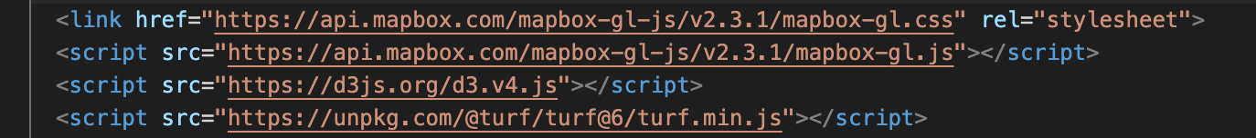

Figure 1 - Main libraries used for the prototype

Table of Contents

Introduction 1

Page Structure 4

1. Landing Page/Cities 5

2. Simulation Results 7

3. Charging Results 12

4. GHG Emission Analysis 15

5. Electricity Cost Estimation 18

6. About 20

7. Contact Us 21

Code Components 22

Mapbox 22

D3.JS 23

Assets 25

Access the Prototype 26

Host the HTMLs 26

Download As PDFs or Images 26

Summary 27

Table of Figures

Figure 1 - Main libraries used for the prototype 1

Figure 2 - The Landing page: A national map with all the CUTRIC cities 5

Figure 3 - The Landing page: Zoomed-in view of the city of Burlington 6

Figure 4 - Main codes for the city listing functions 6

Figure 5 - Customize the link under Feature Properties 6

Figure 6 - The Simulation Results page 7

Figure 7 – Example of Drop down menu 8

Figure 8 - Drop down menu code and graphs inside 8

Figure 9 - Range Analysis – Weekday 9

Figure 10 - Range Analysis – Saturday and Sunday 9

Figure 11 – Bus #1’s range analysis [Figure 9 in the Burlington Report] 9

Figure 12 - Success rate of one-to-one replacement of diesel buses with BEBs 9

Figure 13 - Success rate of one to one replacement of diesel buses with BEBs without a diesel heater [Figure 5 in the Burlington report] 10

Figure 14 - Interaction between the graph and the map 11

Figure 15 – The bus animation function 12

Figure 16 - The recovery time for Saturday vehicles graph 13

Figure 17 - Details of Bus #1 and Bus #2 14

Figure 18 - Energy Consumption of Charging Results 14

Figure 19 - Bus #1 vs. Bus #2 Medium Duty Electricity Consumption on Weekday, Saturday, Sunday 15

Figure 20 – Bus #1 vs. Bus #2 Medium Duty Electricity Consumption Weekly, Monthly, Annual 15

Figure 21 - A comparison chart of 2019 total GHG Emissions by diesel buses vs. BEBs 16

Figure 22 - 2019 Diesel usage by diesel buses at Burlington Transit 17

Figure 23 – 2019 Diesel usage by diesel buses at Burlington Transit [Table 14 in the Burlington report] 17

Figure 24 - Annual GHG emissions from electricity(no diesel heater) 17

Figure 25 - Annual GHG emissions from electricity [Table 15 in the Burlington report] 17

Figure 26 – Monthly cost comparison between diesel buses and BEBs [Figure 28 from the Burlington report] 18

Figure 27 - Monthly cost comparison between diesel buses and BEBs 19

Figure 28 - Icon set 19

Figure 29 - The About page 20

Figure 30 - The Contact page 21

Figure 31 - Mapbox libraries 22

Figure 32 - Add maps to HTML 22

Figure 33 - Add any map related functions under map.on ('load', function(){}) 22

Figure 34 - How to embed a graph from Observable 23

Figure 35 - Fork the notebook to start editing 24

Figure 36 - Replace the data 24

Figure 37 - Asset overview in Excel spreadsheet 25

Figure 38 – Github package 26

Figure 39 – GoFullPage extension on Google Chrome 27

Figure 40 – Examples of GoFullPage captures 28

# Page Structure

The Nav Menu consists of 7 items:

1. Cities

Also known as the landing page. This page will host a national map with all the CUTRIC member cities from which the user can choose. The user can always go back to the landing page to explore a different city.

2. Simulation Results

This page will host all the on-map visualizations with simulation results for range analysis.

3. Charging Results

This page will host all the standalone graphs related to charging, recovery time, and energy consumption outlined with charging metrics.

4. GHG Emissions Analysis

This page will host any standalone graphs related to the GHG emission analysis.

5. Electricity Cost Estimation

This page will host any standalone graphs related to the transit cost.

6. About

This is where CUTRIC could include any information about this project or the team.

7. Contact

This page will host any contact information.

## 1. Landing Page/Cities

The prototype begins with a landing page to help the user navigate the dashboard. On the page there is a map with a list of city names for the user to browse all the current Canadian cities at a national level. Users can select one city to review, by choosing the city’s name either on the side bar or on the map directly.

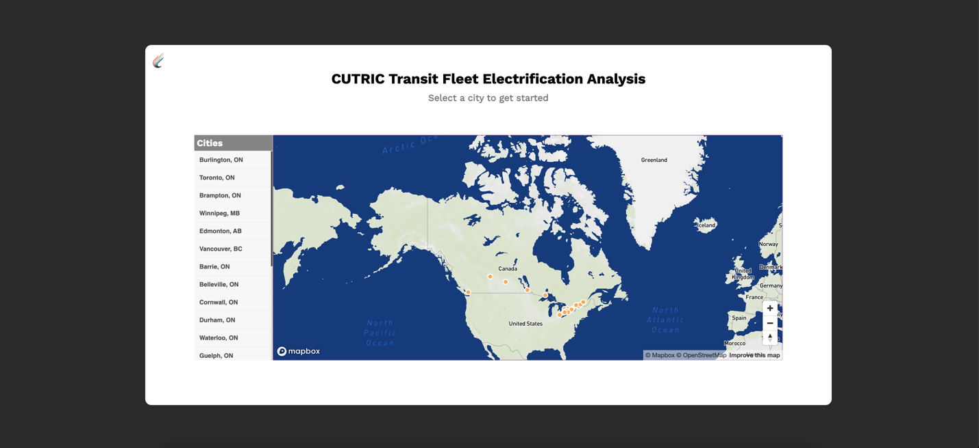

Figure 2 - The Landing page: A national map with all the CUTRIC cities

Originally centred around Canada, the map will move to and zoom in between different cities based on the user’s selection. Once the user selects a city, the map opens to the city’s location and zooms in to the city level. An orange ‘Enter’ button shows up and when the user hovers over it, the city’s name pops up in the tooltip. After confirming the city choice that the user can click on the ‘Enter’ button, and will be taken to another webpage where they can find all the analytics and visualizations of that specific city. Each city will be hosted on a separate site/dashboard, for the ease of data organization and user navigation. For this prototype, only the demonstration case study of Burlington has a functional link.

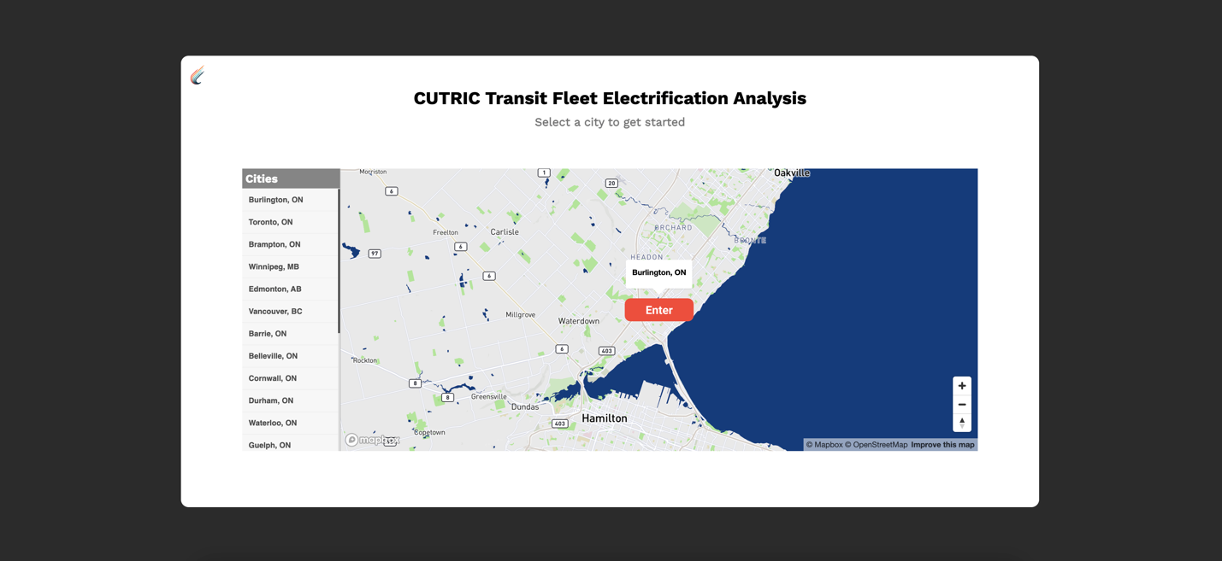

Figure 3 - The Landing page: Zoomed-in view of the city of Burlington

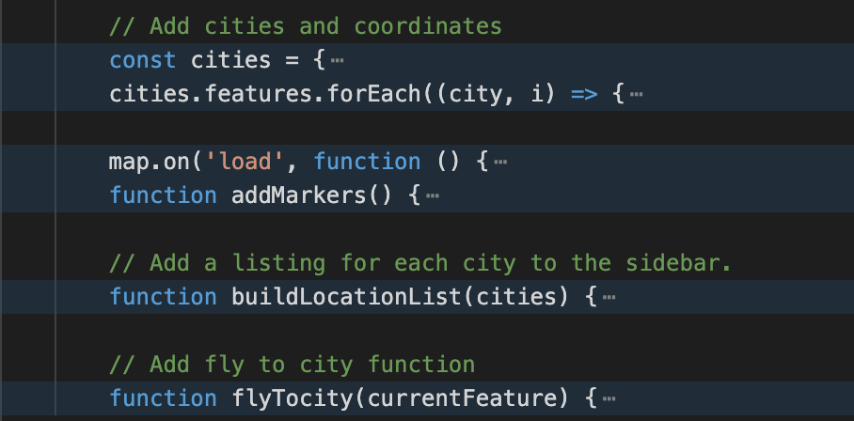

Figure 4 - Main codes for the city listing functions

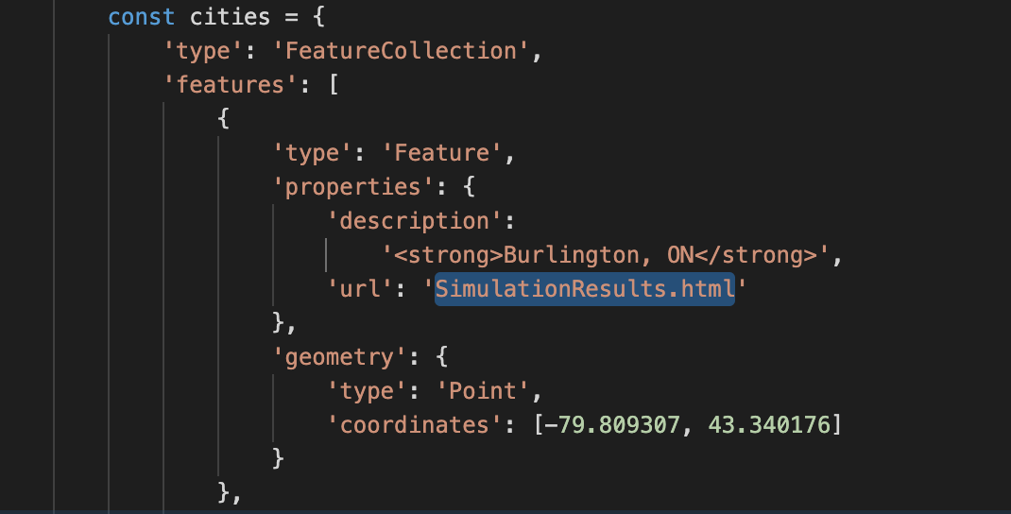

Figure 5 - Customize the link under Feature Properties

## 2. Simulation Results

All the map-related visualizations will live on this page. The top half of the screen consists of two maps for comparing two types of electric buses: the map on the left visualizes Bus #1(Battery 400+ kWh, Weight ~15,000 kg), and the map on the right visualizes Bus #2(Battery 600+ kWh, Weight ~ 15,000 kg). The movement between two maps are synchronized. Basic map navigation controls are added to the map, including a geocoder search bar, zoom in/zoom out, and reset bearing to north. The Geocoder Search Bar allows the user to type in a street name, coordinates with latitude and longitude, or other descriptions of a location, and move to that location on the map. On the left side of each map there are menus to toggle on and off map layers, including: 1) contours; 2) hillshade; 3) all the bus routes in Burlington; 4) all the bus stops.



On the map, the user can find the legends for all the potential electric bus charger locations with pop-up details through hovering.



On the right bottom corner of each map, there are two icons that will each take the user to the GHG Emissions Analysis page and the Electricity Cost Estimation page.

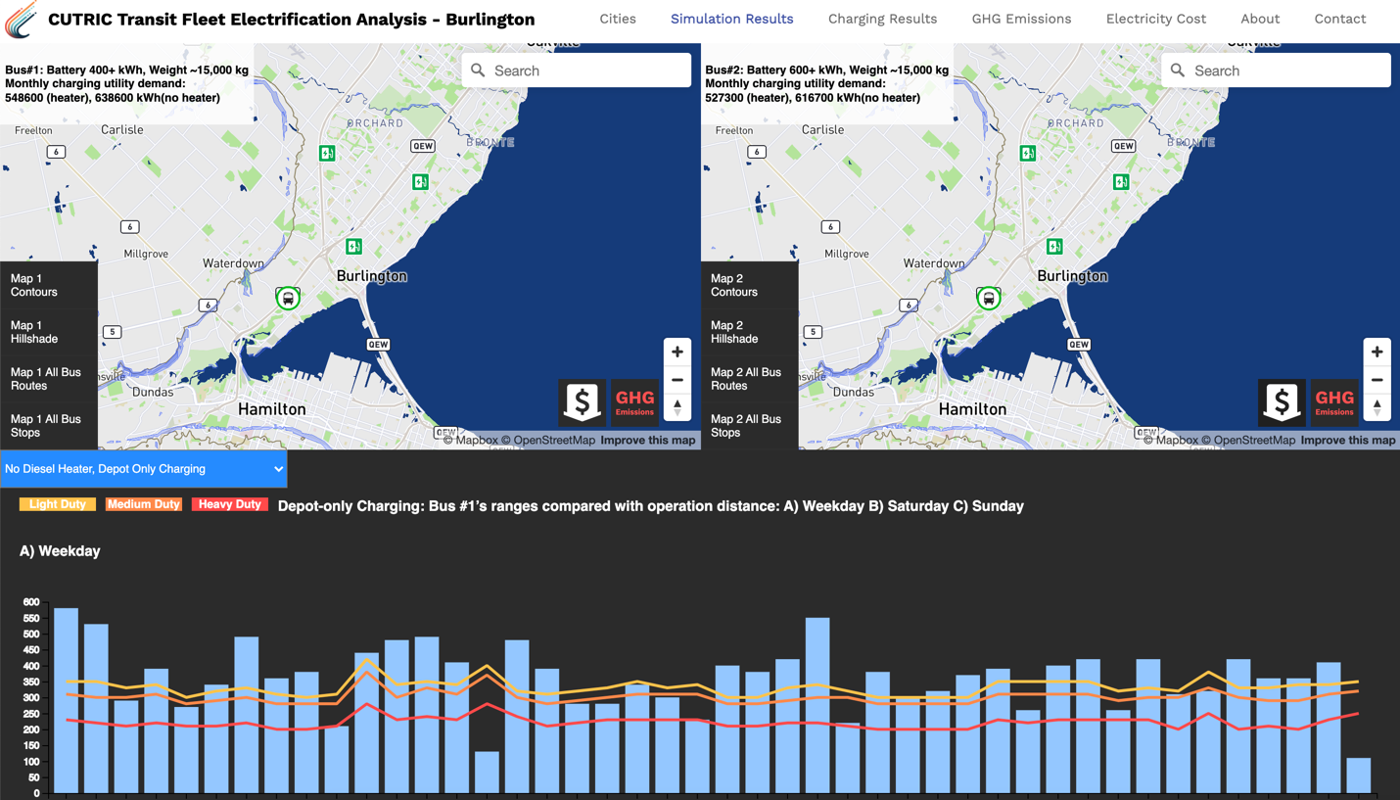

Figure 6 - The Simulation Results page

At the bottom half of the page, there is a drop-down menu to select between four sets of graphs: 1) No Diesel Heater, Depot Only Charging; 2) Diesel Heater, Depot Only Charging; 3) No Diesel Heater, Opportunity Charging; and 4) Diesel Heater, Opportunity Charging. Each set of graphs contains Range Analysis graphs for weekdays, Saturday, and Sunday, categorized by bus #1 and bus #2; and the success rate of one-to-one replacement of diesel buses with BEBs.

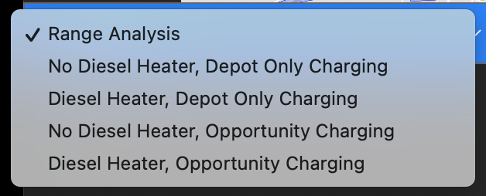

Figure 7 – Example of Drop down menu

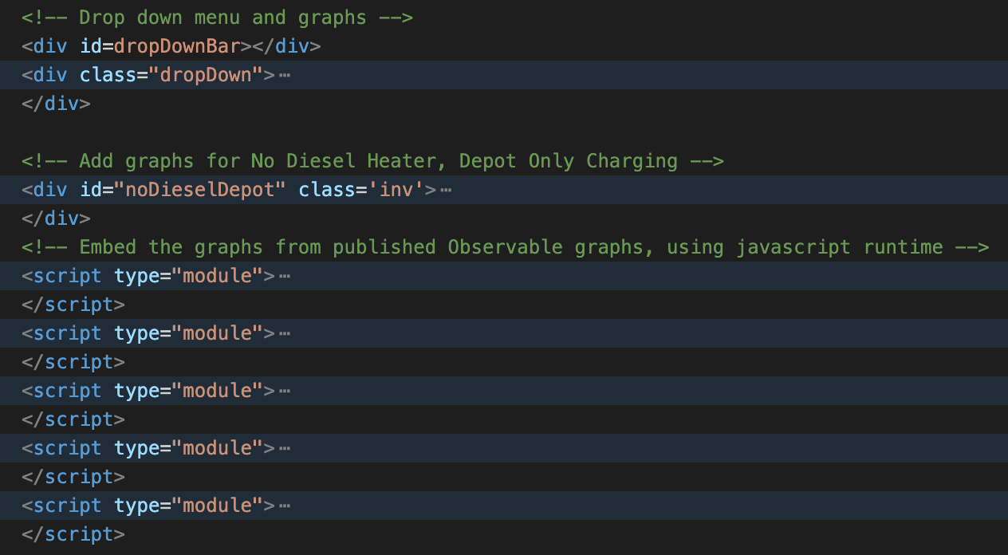

Figure 8 - Drop down menu code and graphs inside

The range analysis graphs are based upon the graphs in the CUTRIC Burlington report. The data was roughly extracted from the graphs with non-accurate numbers because we were not able to obtain the raw data. Please note that only one set of the range analysis graphs was created based on “Figure 9. Bus #1’s ranges after using diesel heater compared with operation distance: A) Weekday B) Saturdays C) Sundays” and “Figure 5. Success rate of one-to-one replacement of diesel buses with BEBs without a diesel heater (summer and winter are the same)” from the report. We used this set of graphs repetitively under all four dropdowns to show how several graphs can be displayed to cover all four situations. When hovering over each blue bar, more details will be displayed on a tooltip.

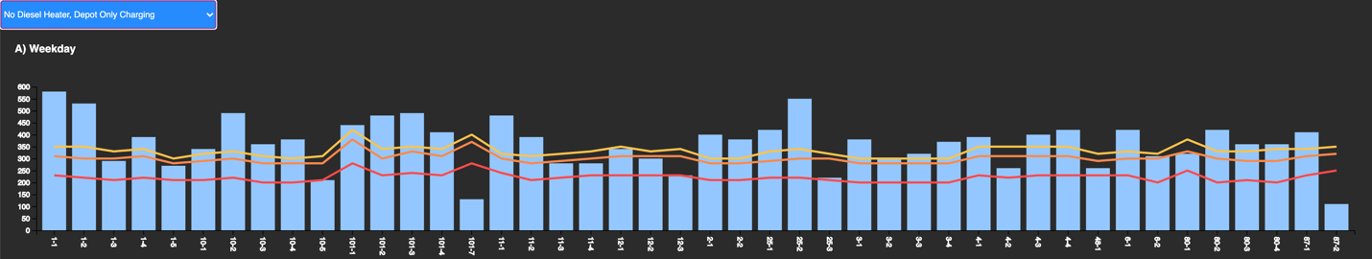

Figure 9 - Range Analysis – Weekday

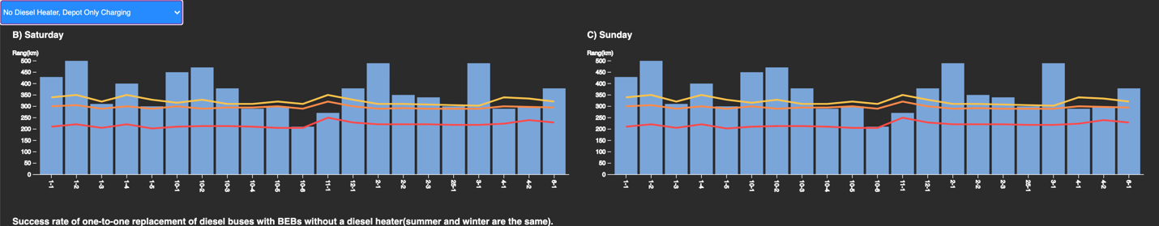

Figure 10 - Range Analysis – Saturday and Sunday

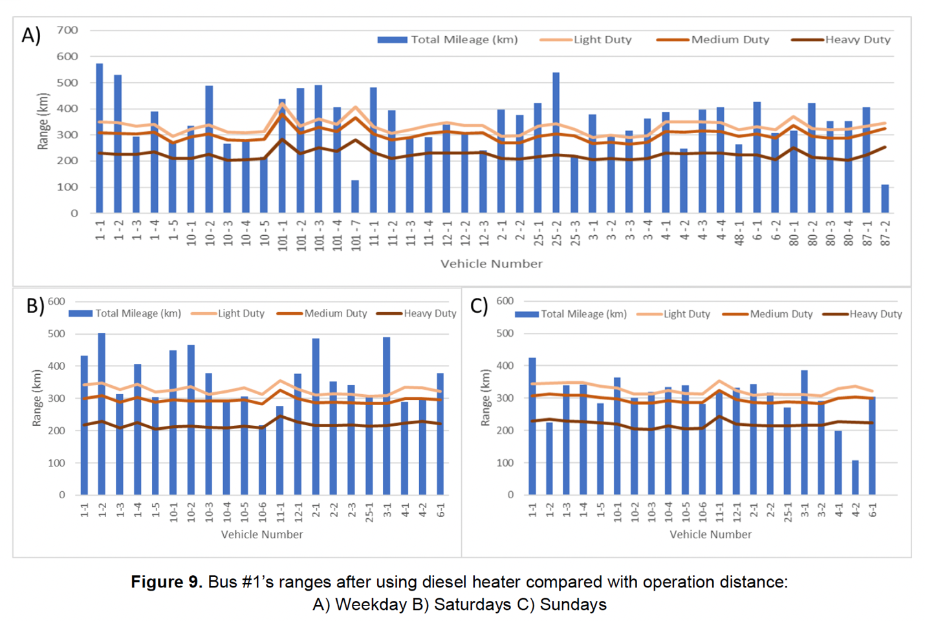

Figure 11 – Bus #1’s range analysis [Figure 9 in the Burlington Report]

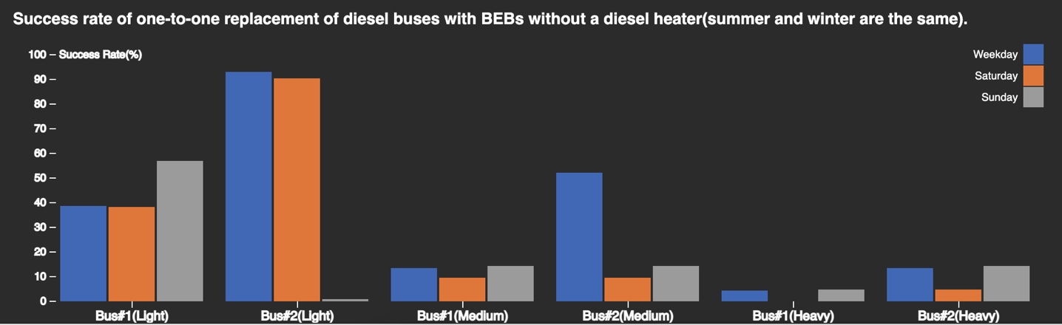

Figure 12 - Success rate of one-to-one replacement of diesel buses with BEBs

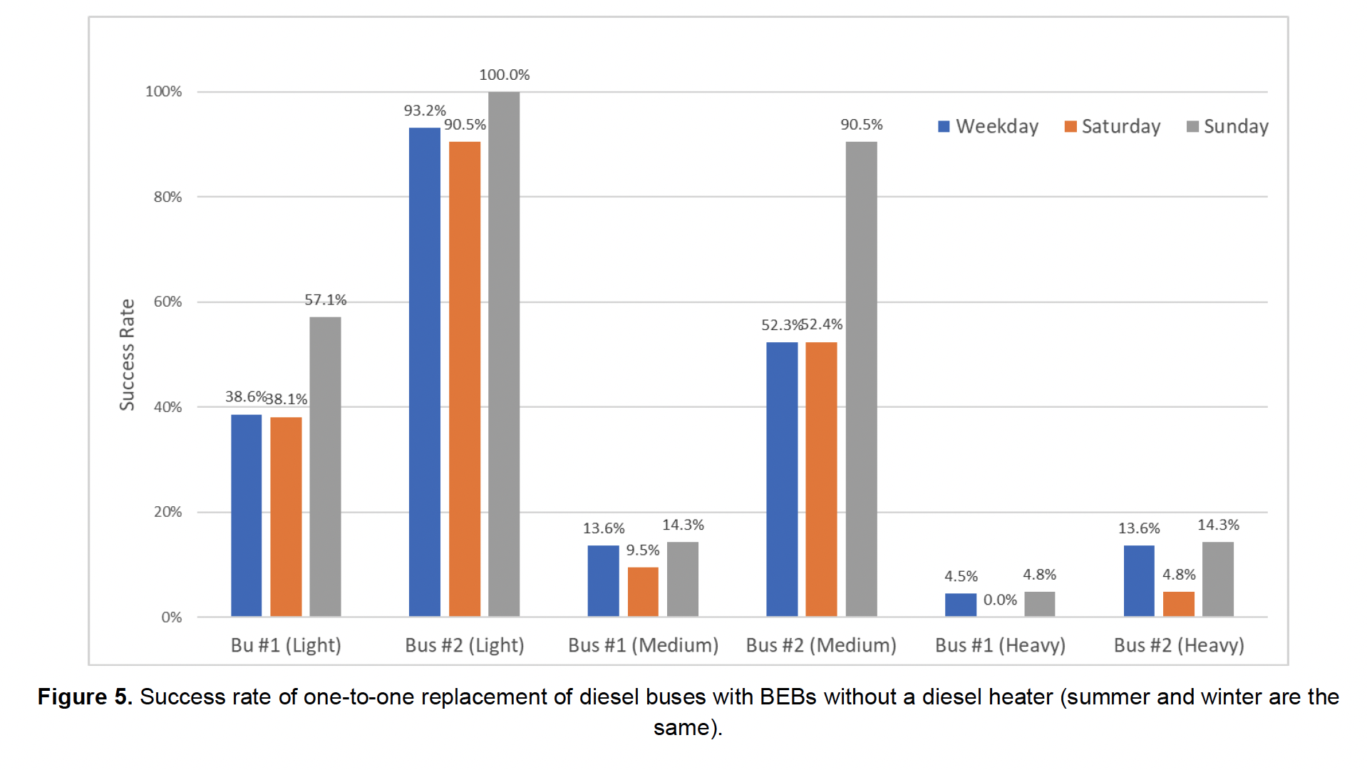

Figure 13 - Success rate of one-to-one replacement of diesel buses with BEBs without a diesel heater [Figure 5 in the Burlington report]

We implemented the interaction between the graphs and the maps by animating a bus icon displayed as a bus running on a route. Bus 1 and Bus 2 on route 4 are selected to be prototyped with animation. When the user clicks on the 4-1 or 4-2 blue bar on the Bus #1 or Bus #2, the Weekday graph under the second drop-down item “No Diesel Heater, Depot Only Charging”, the corresponding bus will start running along the route on the map. The outer circle of the bus icon has the potential to represent the battery status of the bus. Note that animation has only been implemented to those two graphs for 4-1 and 4-2 buses as a demonstration. The two graphs are added to the html directly with JavaScript codes instead of Observable JavaScript runtime data import.

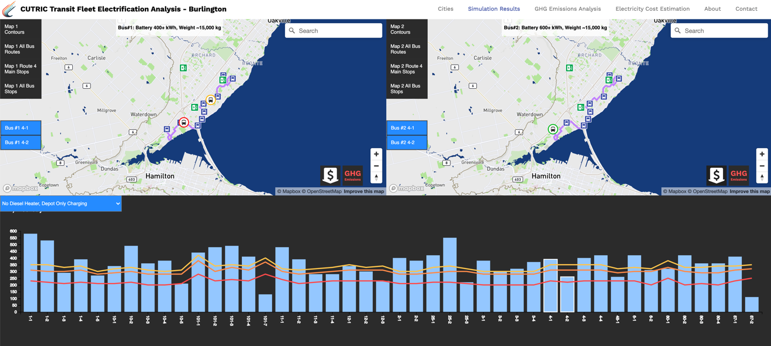

Figure 14 - Interaction between the graph and the map

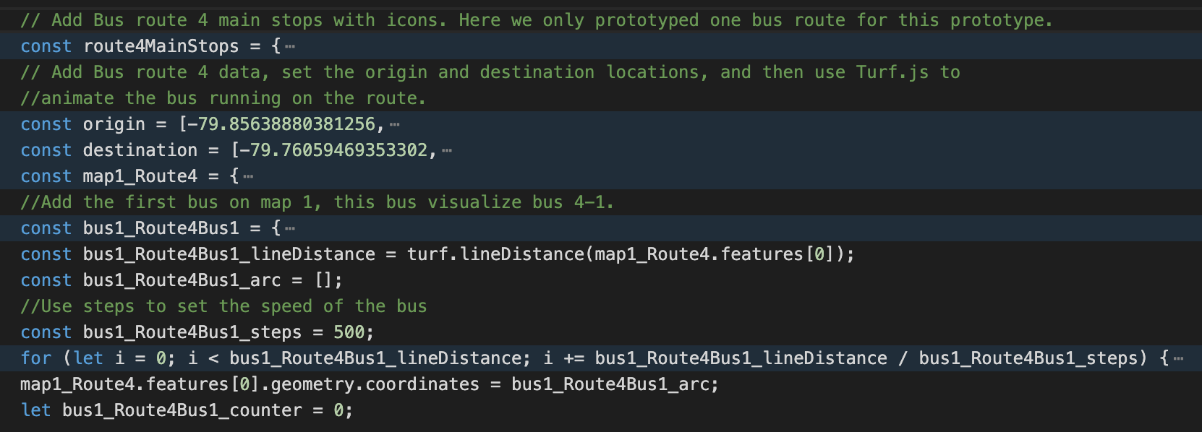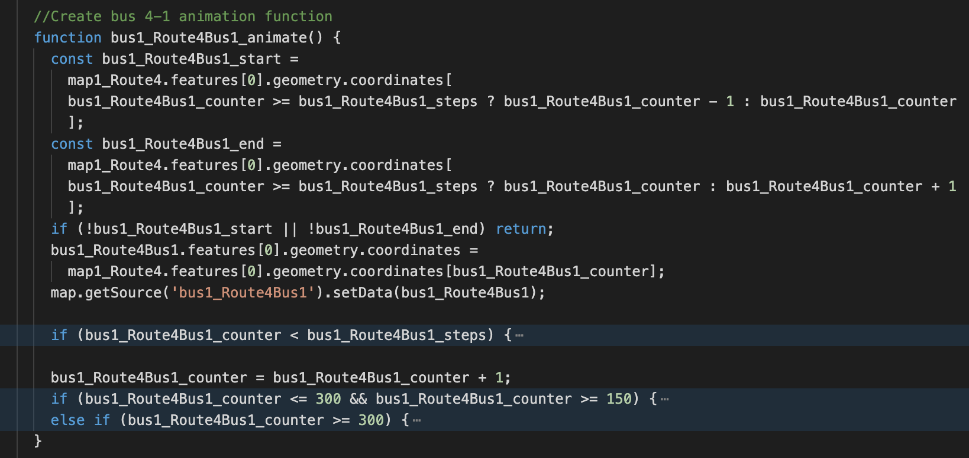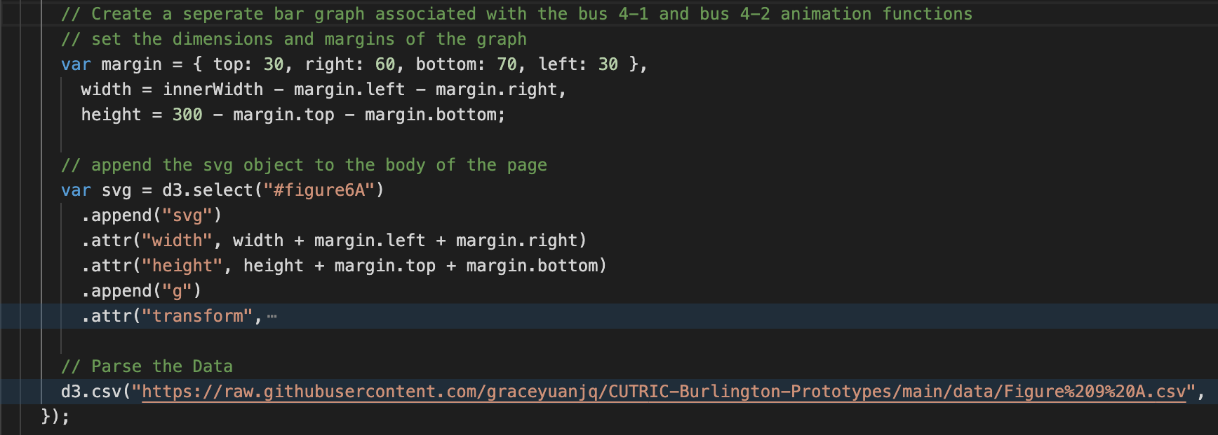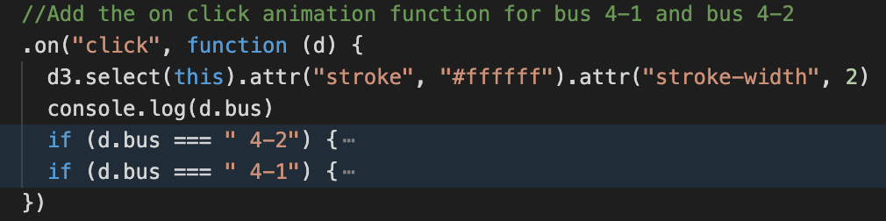

Figure 15 – The bus animation function

## 3. Charging Results

On this page, the user will find two types of graphs related to the charging and energy consumption.

The first graph represents the failed and success recovery time proportionally for Saturday vehicles, based on trip counts. The required recovery time for opportunity charging is 5 minutes, thus, any trip with less than 5 minutes recovery time fails. For future development, Weekday and Sunday vehicles should be visualized as well.

For this graph, the X-axis shows the bus route numbers, while the Y-axis shows the count of trips on the route. It aims to show among all the routes, which ones are more suitable for opportunity charging verses the ones that are not. The color variations represent the different recovery time needed for the trips. The red colors refer to the trips that fail to meet the 5 minute requirement, and the blue colors refer to the trips that meet the 5 minute requirement successfully.

We utilized the “BT_RecoveryTime_Saturday” data and sorted out the trip counts based on recovery time and generated the data set “Recovery time Saturday.csv” that is used to create this graphical representation.

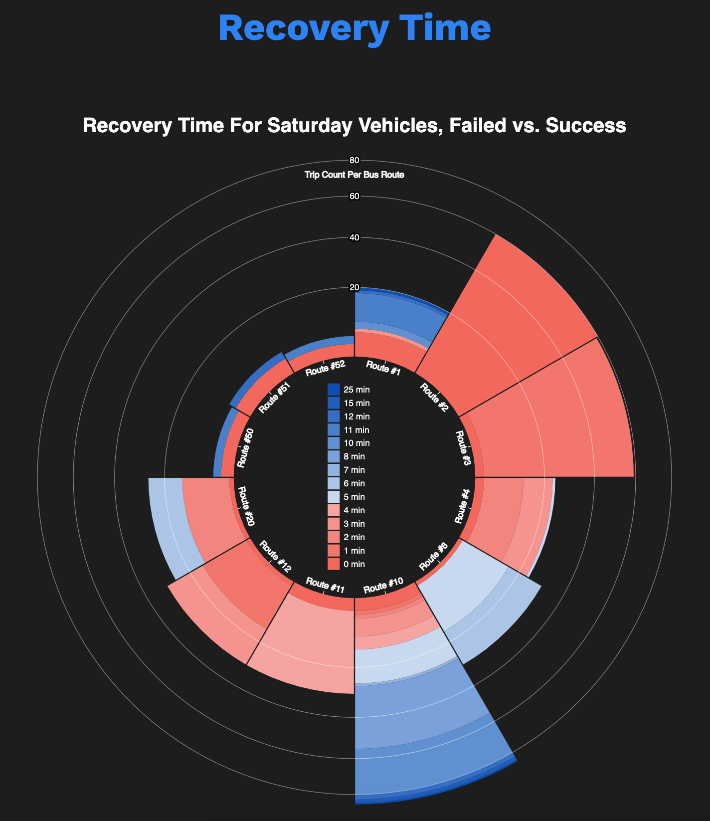

Figure 16 - The recovery time for Saturday vehicles graph

The second part of the page includes three graphs that represent the energy consumption results. Because the results provide comparisons between the energy consumption of Bus #1 and Bus #2, we added the details of both BEB models to inform users of their difference. To distinguish the two bus models visually, we assign Bus #1 with green colors, and Bus #2 with blue colors.

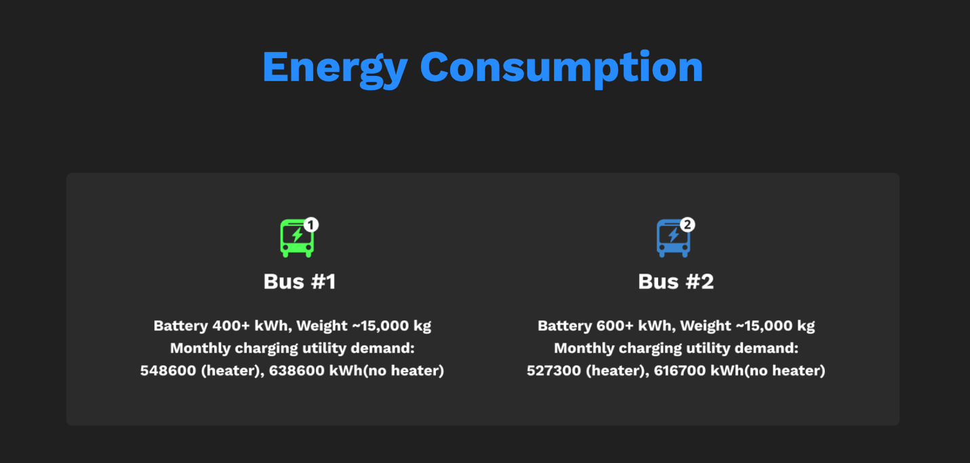

Figure 17 - Details of Bus #1 and Bus #2

The first graph represents the energy consumption of BEB charging results, comparing Bus #1 and Bus #2, no diesel heater and with diesel heater, Weekday, Saturday, and Sunday. When hovering over each bar, the detailed number will show up on the tooltip.

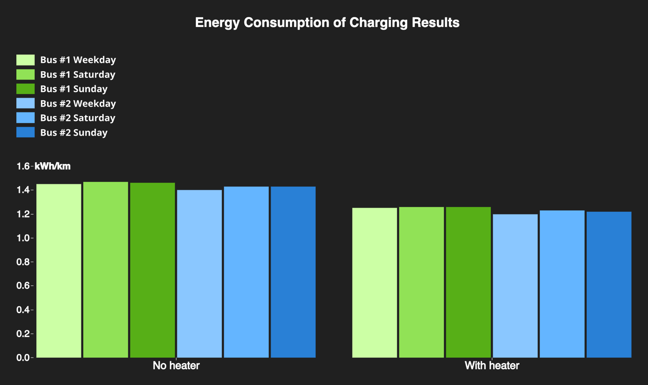

Figure 18 - Energy Consumption of Charging Results

The second graph represents the electricity consumption difference between Bus #1 and Bus #2 on Weekday, Saturday, and Sunday, on medium duty.

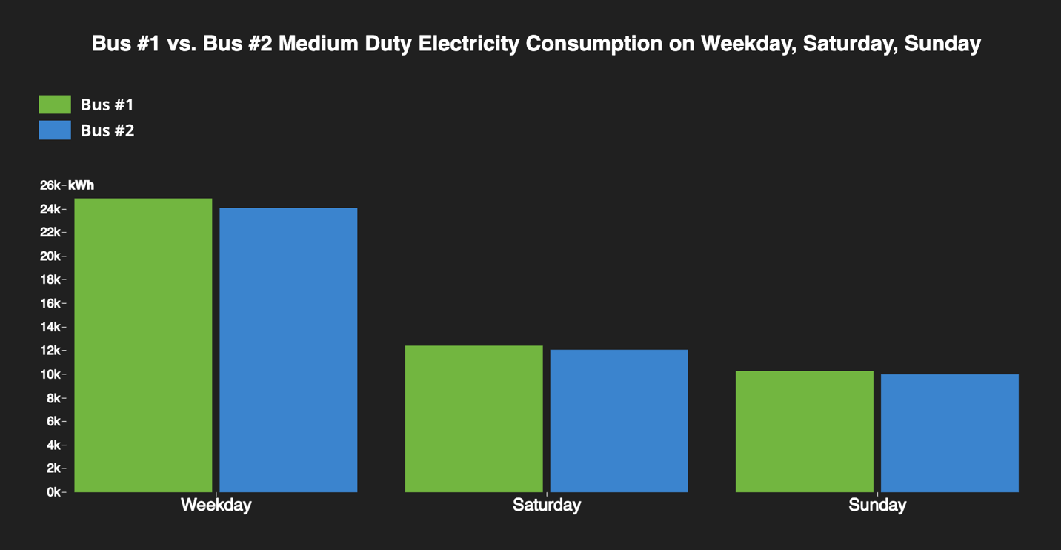

Figure - Bus #1 vs. Bus #2 Medium Duty Electricity Consumption on Weekday, Saturday, Sunday

The last table provides data on the electricity consumption every week, month, and year, for Bus #1 and Bus #2.

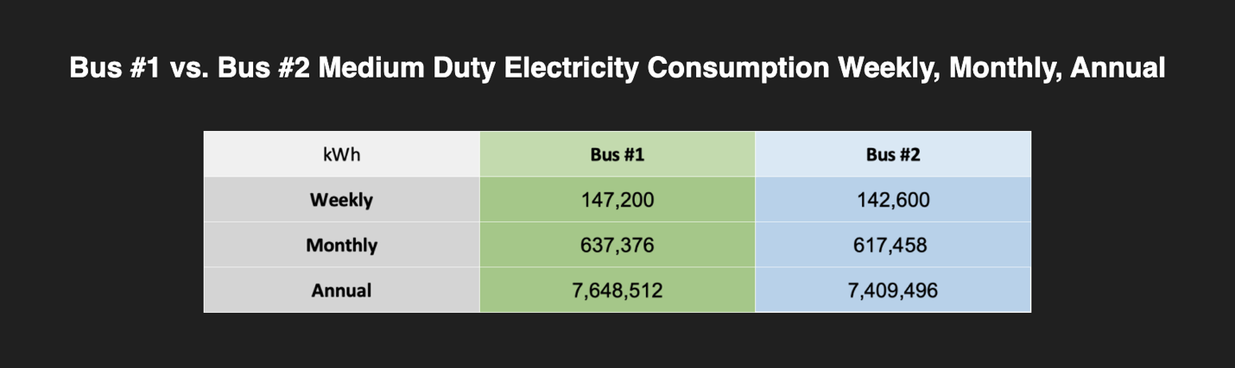

Figure 20 – Bus #1 vs. Bus #2 Medium Duty Electricity Consumption Weekly, Monthly, Annual

## 4. GHG Emission Analysis

On this page, the user will find graphs that visualizes the GHG emission analysis for both diesel bus and electric bus.

The first graph is a comparison chart of 2019 total GHG Emissions by diesel buses vs. BEBs. It is animated to show how the GHG emissions accumulated month by month in 2019, indicated by the name of the month in the bottom right that keeps getting updated when the animation plays. The bars keep growing until they reach the accumulated totals in the year of 2019. The red bars represent diesel bus verses the blue bars represent BEBs. The bus model name is attached at the right end of each bar.

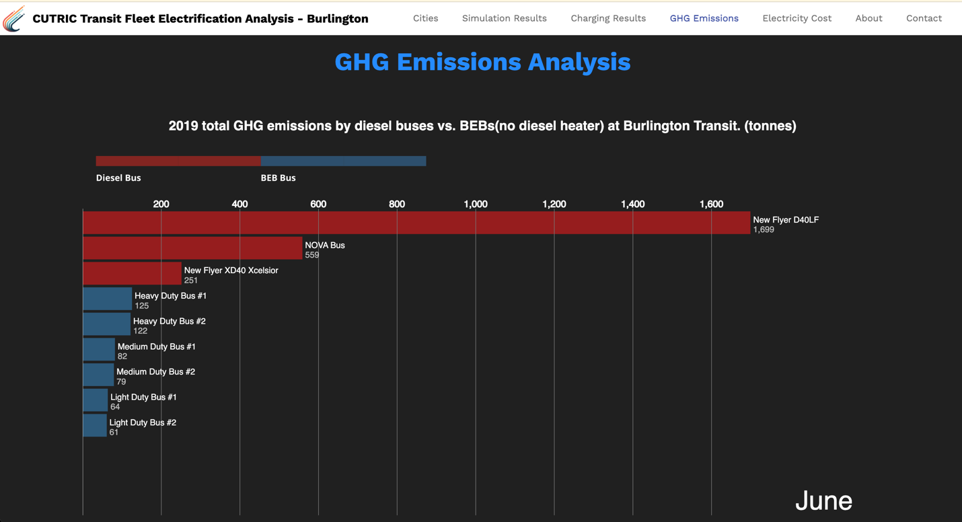

Figure 21 - A comparison chart of 2019 total GHG Emissions by diesel buses vs. BEBs

The second graph is a line chart displaying 2019 diesel usage by three different models of diesel buses at Burlington Transit. It compares the usage by month. The New Flyer D40LF diesel buses appear to have used significantly higher amount of diesel than the other two models. The data was extracted from the Table 14 in the Burlington report.

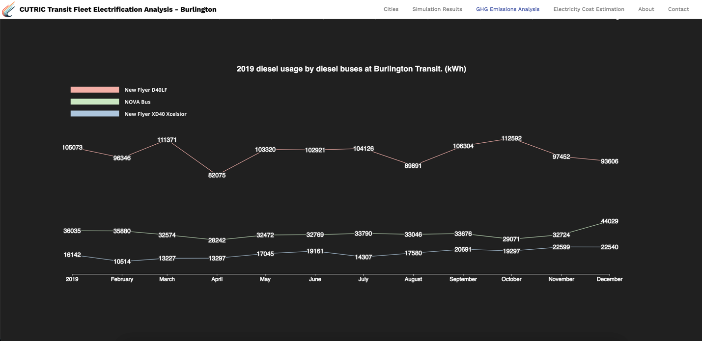

Figure 22 - 2019 Diesel usage by diesel buses at Burlington Transit

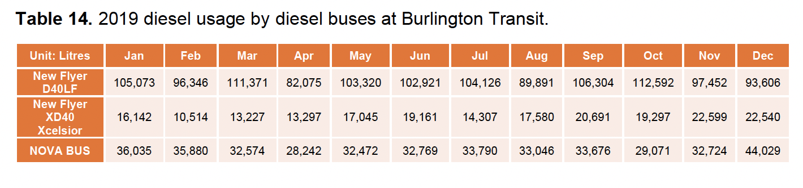

Figure 23 – 2019 Diesel usage by diesel buses at Burlington Transit [Table 14 in the Burlington report]

The third graph is a grouped bar chart displaying annual GHG emissions from electricity, based on data from Table 15 in the Burlington report. It compares the annual GHG emissions of Bus #1 and Bus #2 on Light duty, Medium duty and Heavy duty.

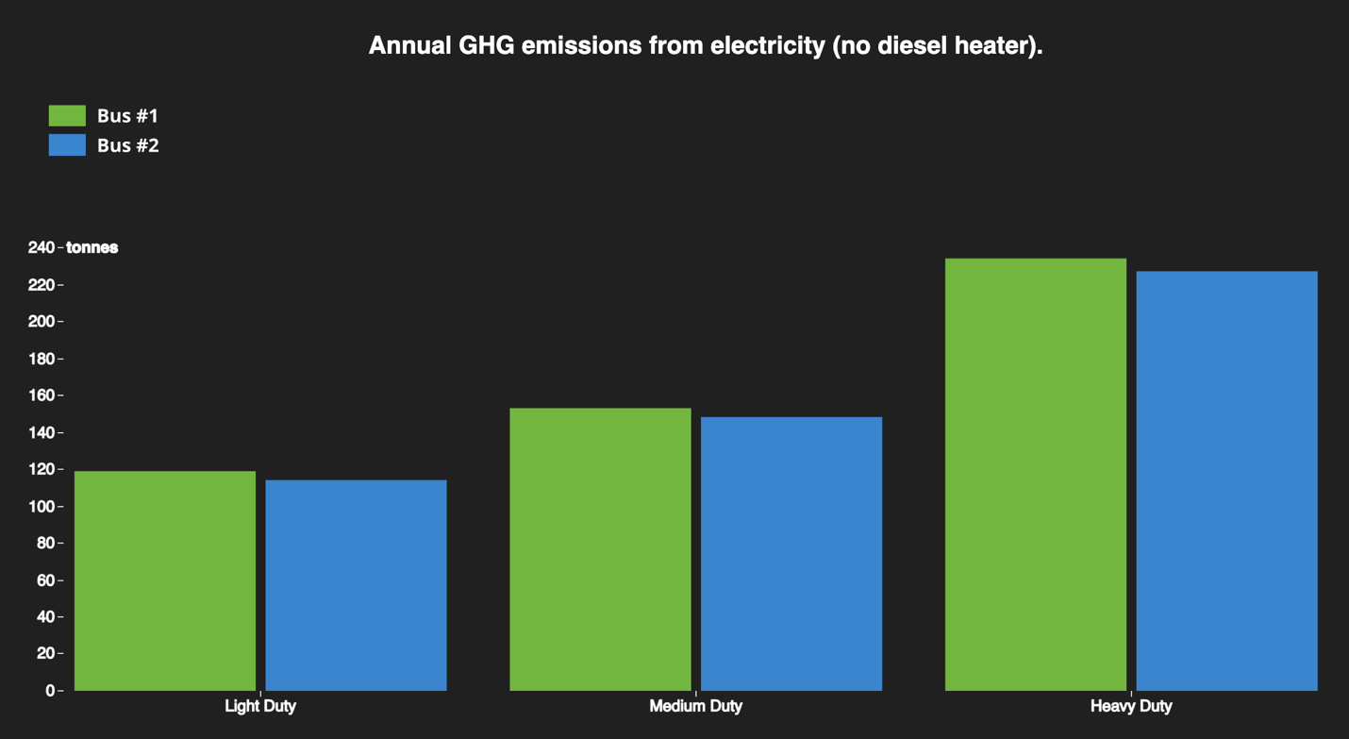

Figure 24 - Annual GHG emissions from electricity (no diesel heater)

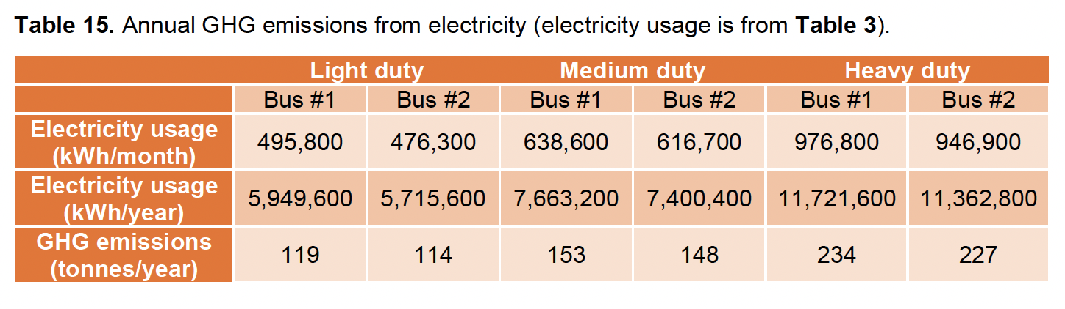

Figure 25 - Annual GHG emissions from electricity [Table 15 in the Burlington report]

## 5. Electricity Cost Estimation

On the Electricity Cost Estimation page, the user will find graphs that visualizes electricity cost estimation for both diesel bus and electric bus.

The bar chart on display is based on Table 28 from the Burlington report. We tried to match the color scheme used in the report.

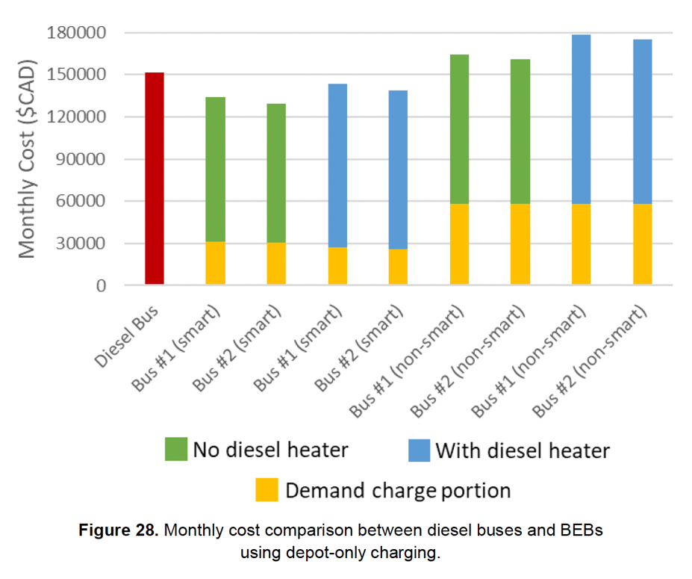

Figure 26 – Monthly cost comparison between diesel buses and BEBs [Figure 28 from the Burlington report]

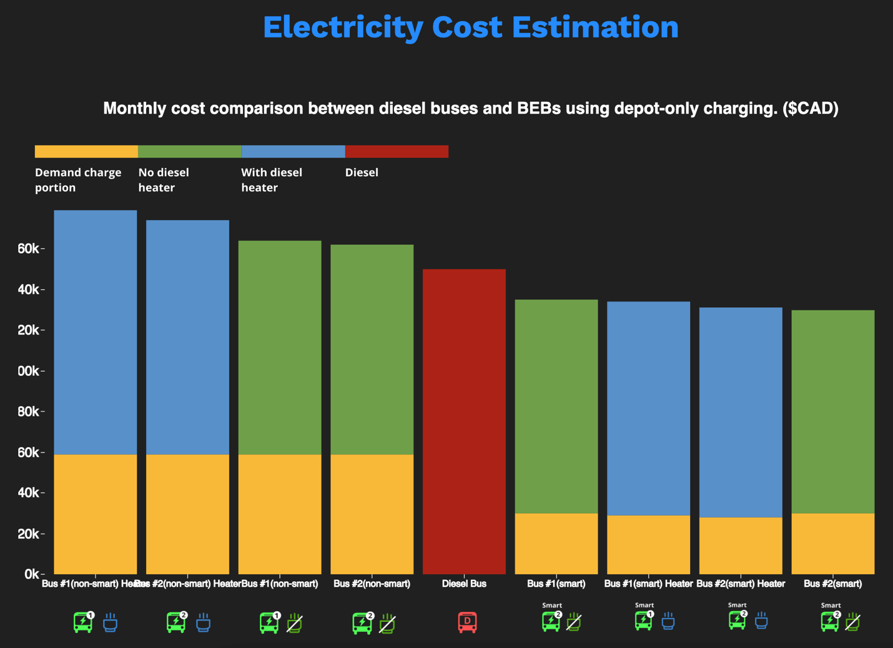

Figure 27 - Monthly cost comparison between diesel buses and BEBs

We developed a set of icons to represent the electric bus vs. diesel bus, smart bus vs. non-smart bus, with diesel heather vs. no diesel heater, bus #1 vs. bus #2. These icons were developed to be utilized on various graphs and to increase readability.

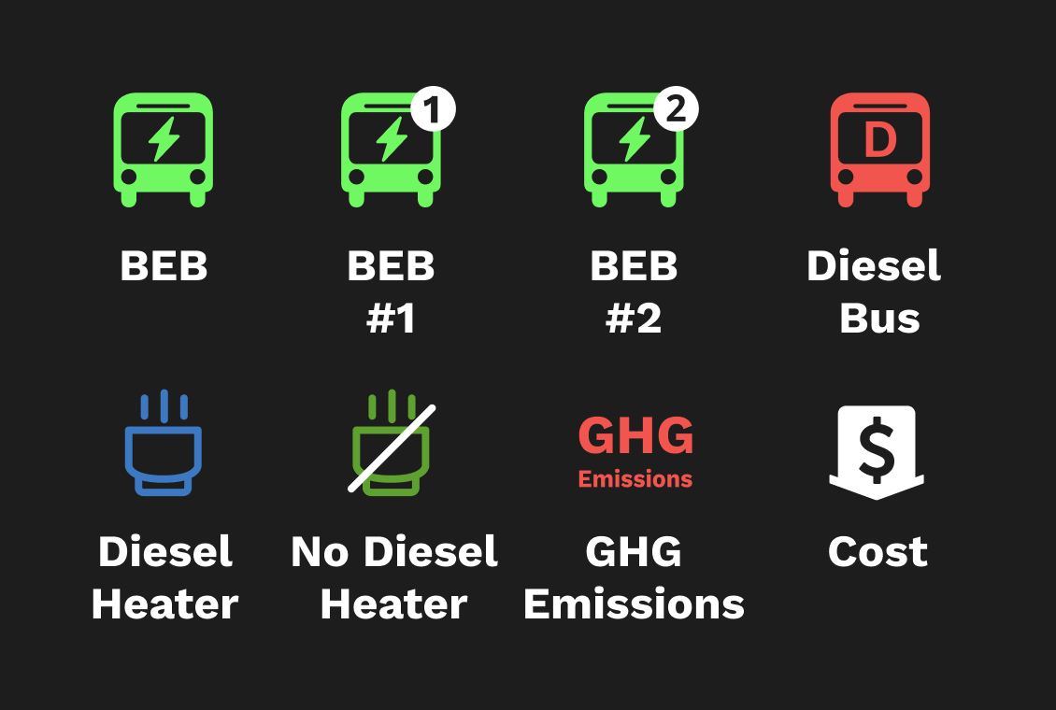

Figure 28 - Icon set

## 6. About

The about page can contain any information CUTRIC would like to show related to the transit analysis or the team. For the prototype, we borrowed some descriptions and one group photo from CUTRIC’s official website, to indicate how this page could be employed potentially.

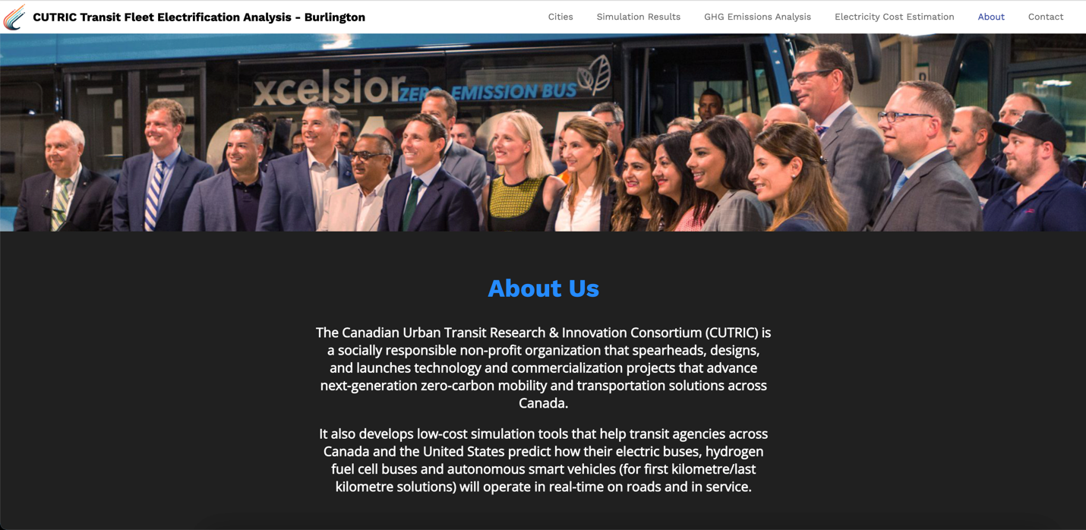

Figure 29 - The About page

## 7. Contact Us

The user will be able to find all the contact information on the Contact Us page. The Email Us button can be customized to redirect to any email address. Again, we borrowed some information and an image from the CUTRIC website to indicate how it can be used as a template.

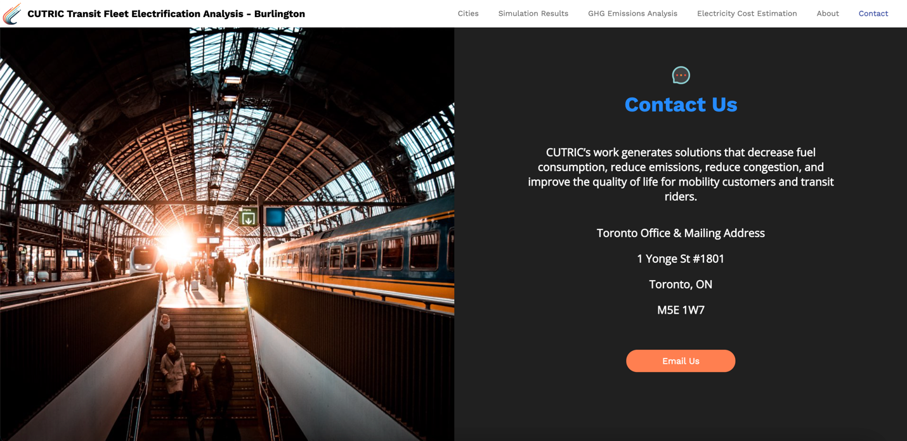

Figure 30 - The Contact page

# Code Components

## Mapbox

To use Mapbox’s functions, the following libraries need to be imported first:

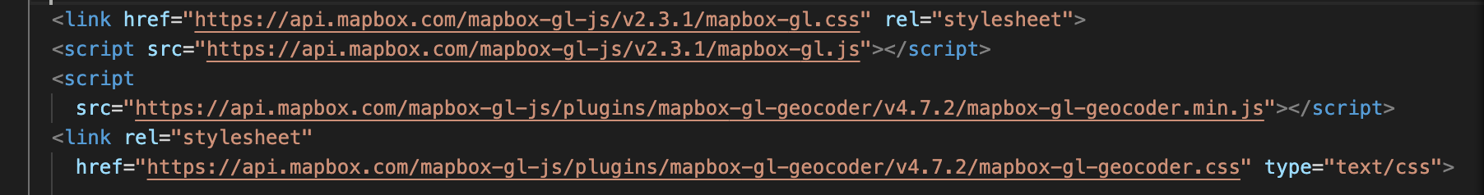

Figure 31 - Mapbox libraries

Add maps to HTML divs with Mapbox access token and customized styles. To access the map style, use the following Mapbox GL username and password:

Mapbox username: graceyuan

Passwords: CUTRICburlington1!

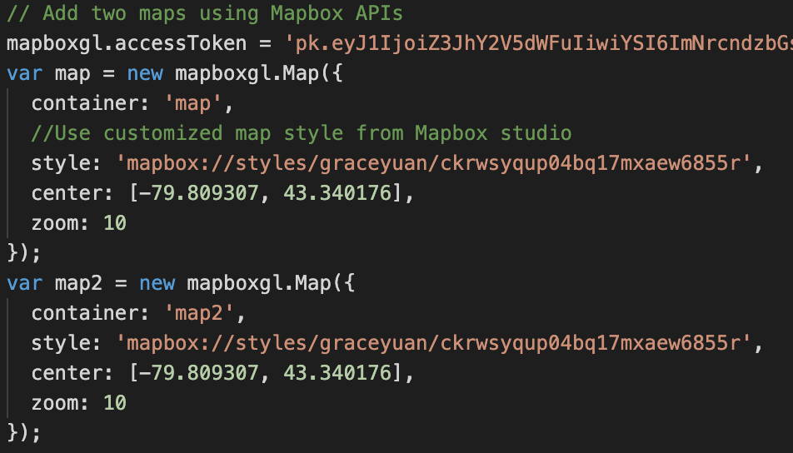

Figure 32 - Add maps to HTML

All the map related visualization layers and functions need to go inside the following functions.

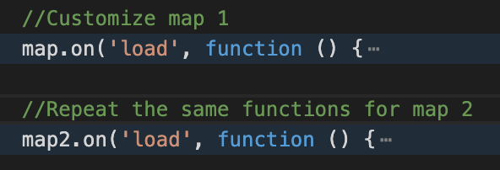

Figure 33 - Add any map related functions under map.on ('load', function(){})

## D3.JS

Most D3.JS graphs displayed in the prototype are embedded through JavaScript runtime from Observable. We decided to go with this approach because 1) it is rather easy to use the existing D3.JS examples which are already hosted on Observable, 2) it lightens the weight of the code used in the local files.

To add a new graph or replace an existing graph on the page, replace the highlighted URL and the div id inside “Inspector(document.querySelector("______")”.

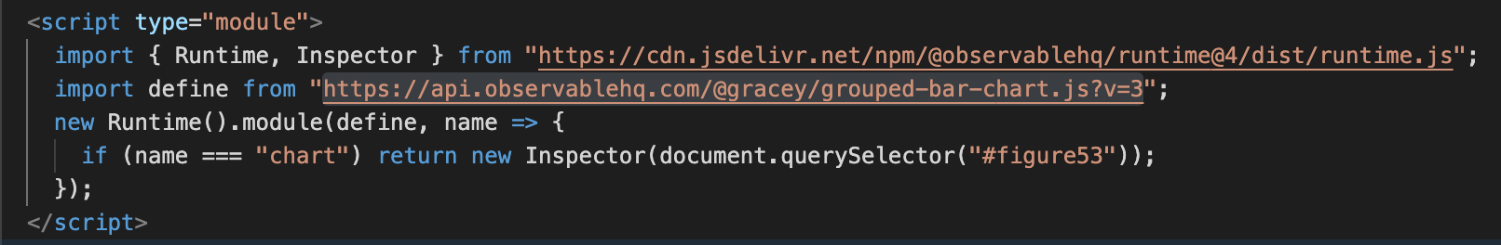

Figure 34 - How to embed a graph from Observable

To edit or reuse a graph from Observable, go to the Observable link which can be found in the asset overview excel, and fork the notebook. Forking a notebook means creating a copy of the notebook without affecting the original file. The forked notebook is still linked to the original notebook and users can check back on it. Users can also compare different forked versions and see the difference between the codes.



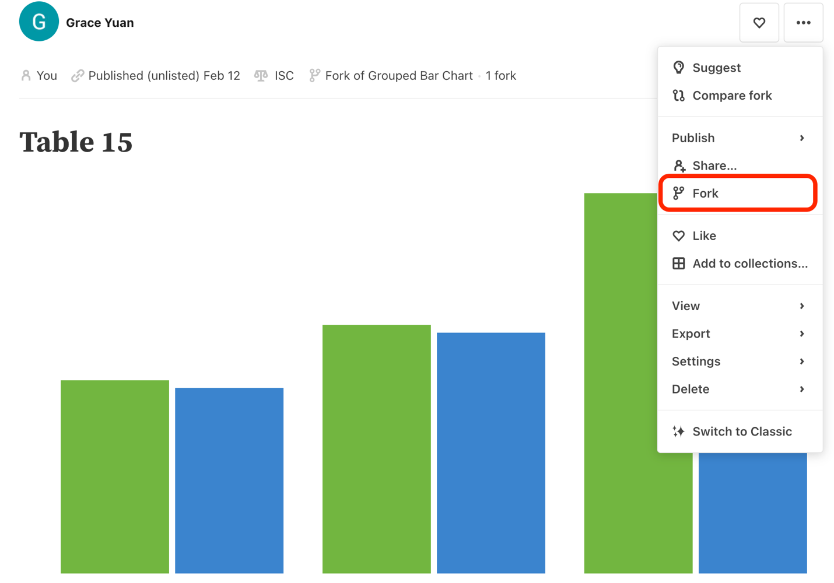

Figure 35 - Fork the notebook to start editing

To replace the data set used in current graph, click on the paper click icon on the right and replace the csv file. For the graph to work, the data set needs to remain the same format as the csv that is currently being used.

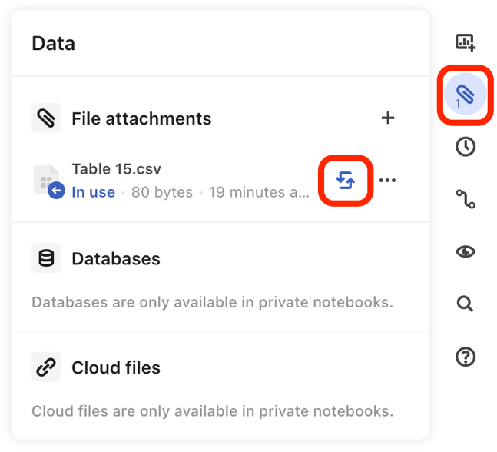

Figure 36 - Replace the data

# Assets

We summarized all the assets and library used in the code in an excel spread sheet. The attached files can be found in the corresponding folders: green – “/data” files; pink – “/image” files, and the blue items are external libraries or Mapbox tile sets.



Figure 37 - Asset overview in Excel spreadsheet

# Access the Prototype

## Download as Interactive Prototype

The prototype package can be downloaded or forked on github: <https://github.com/graceyuanjq/CUTRIC-Burlington-Prototypes>. This documentation word doc can be found in the Documentations folder.

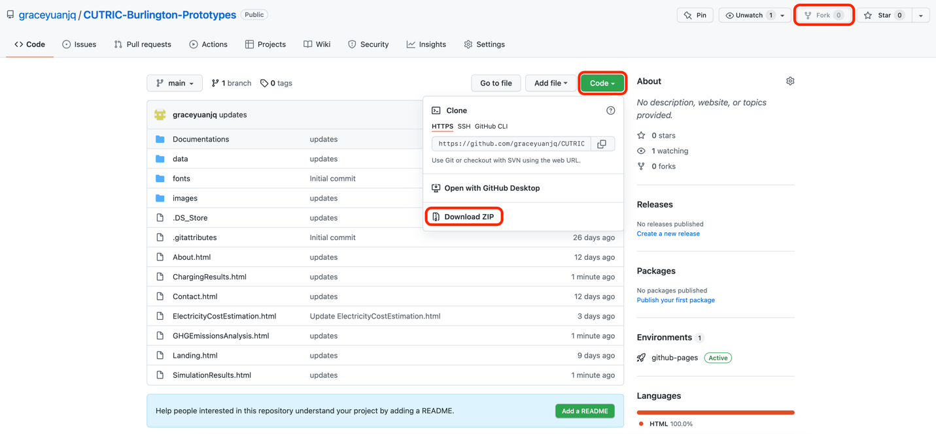

Figure – Github package

## Download As PDFs or Images

To download the prototype as static pdfs or images, we recommend using a free Google Chrome extension called GoFullPage. (<https://chrome.google.com/webstore/detail/gofullpage-full-page-scre/fdpohaocaechififmbbbbbknoalclacl?hl=en>) After adding the extension to Chrome, open the prototype in Google Chrome, click on the puzzle icon in the right top corner of the task bar to access all extensions, and click on GoFullPage to capture the current web page.

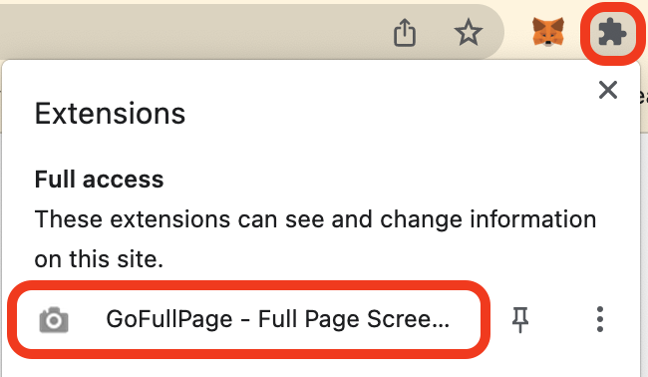

Figure 39 – The GoFullPage extension on Google Chrome

GoFullPage lets the user to download the full length of a HTML page as either pdf or image. These can be used for presentations or documentations.

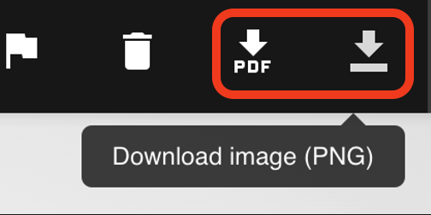

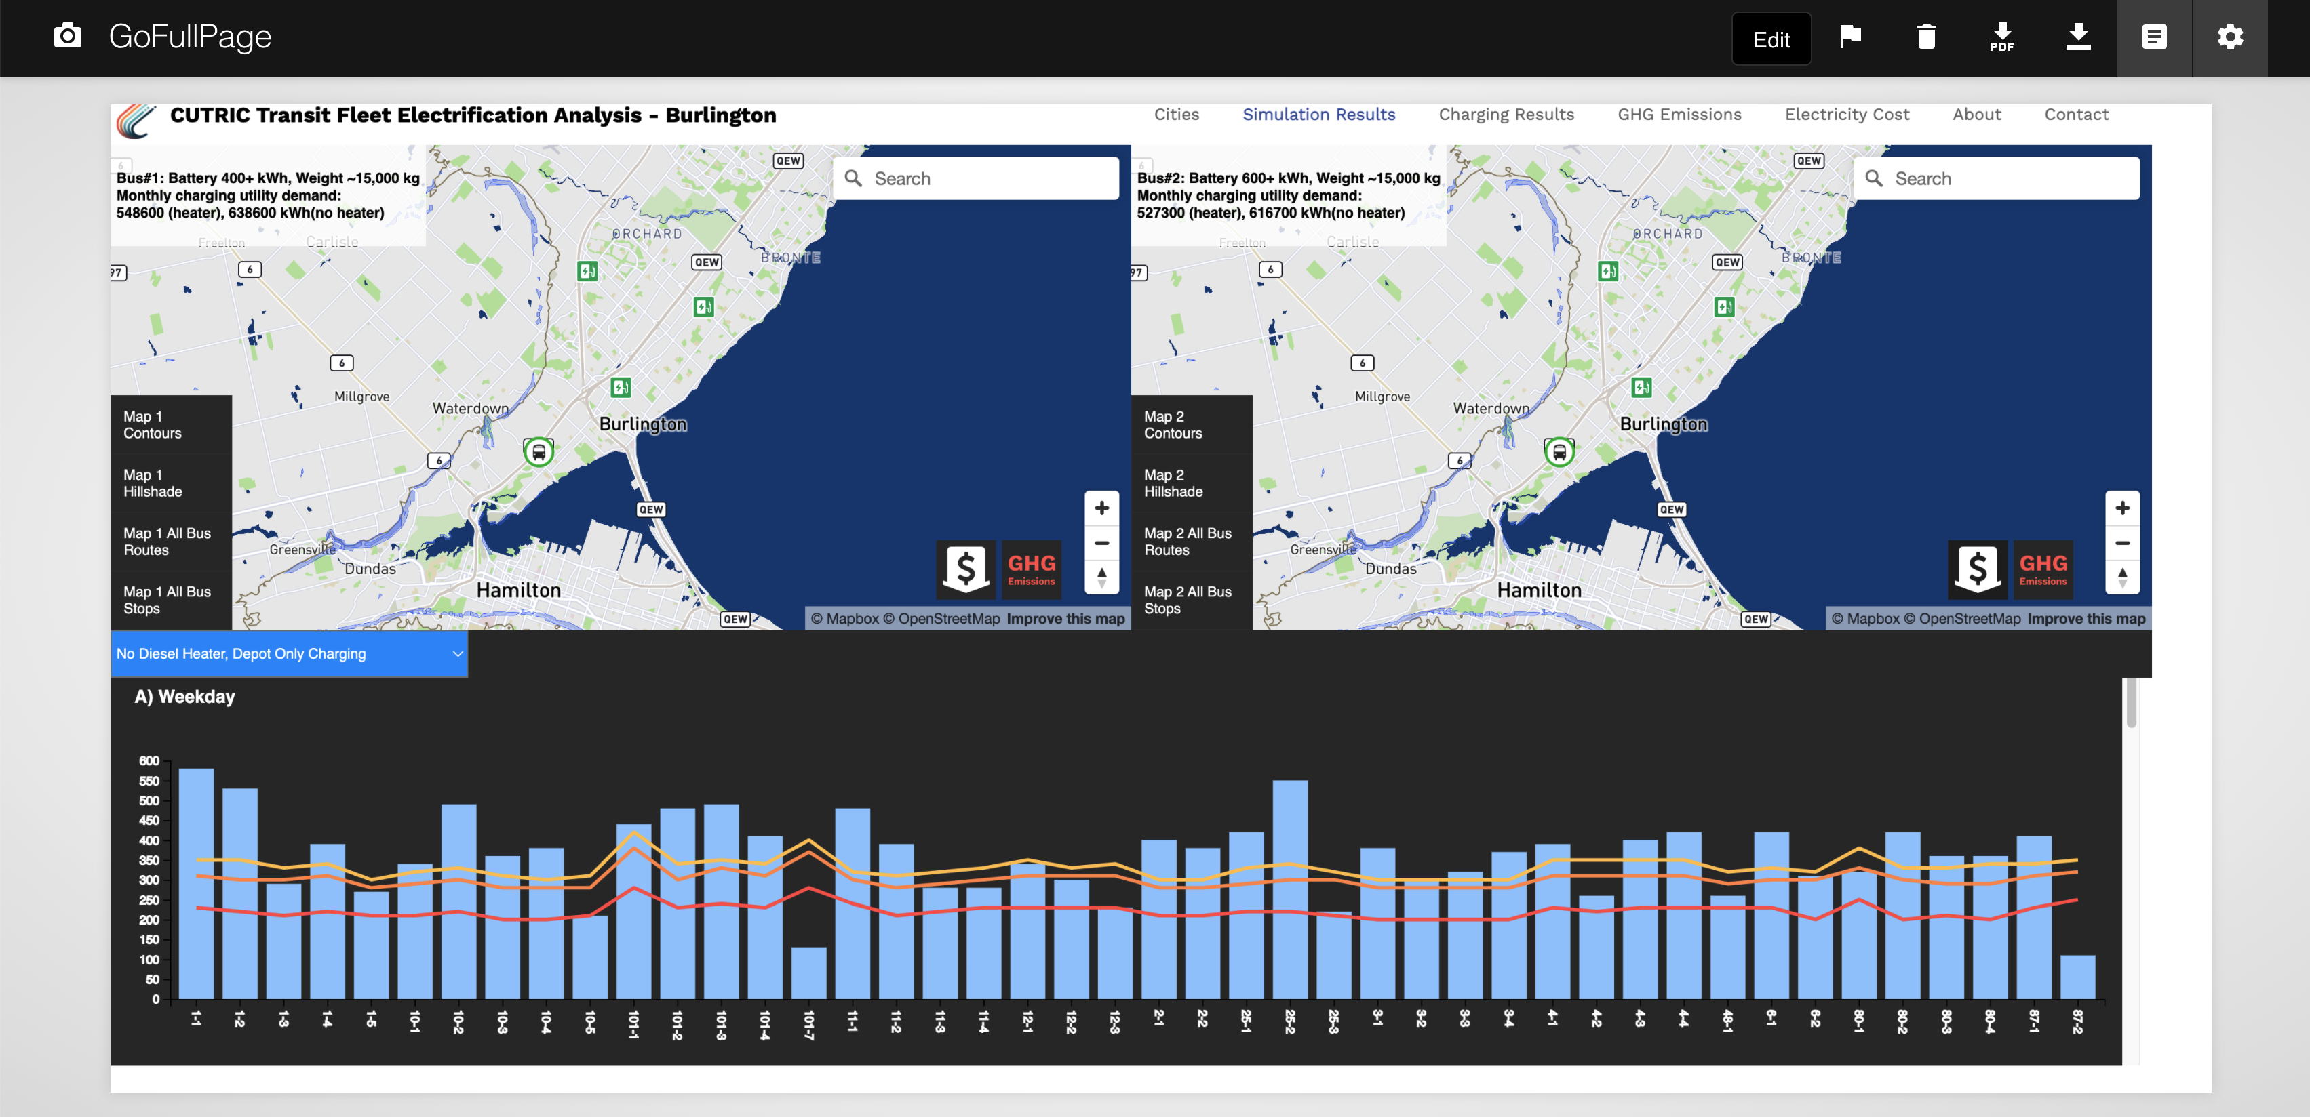

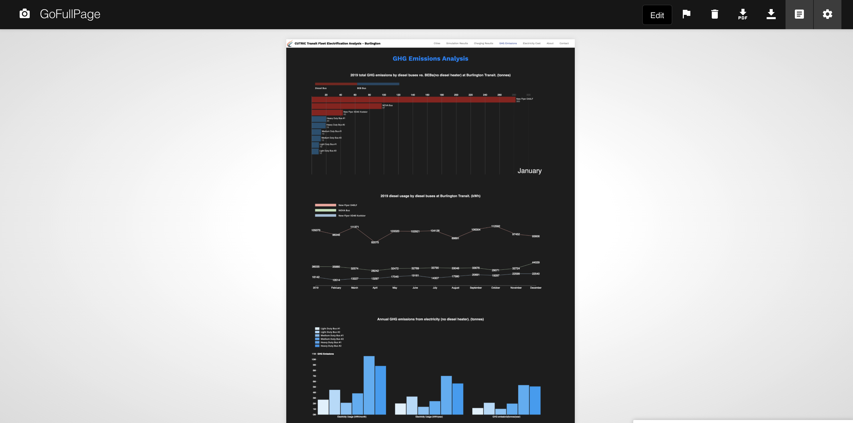

Figure 40 – Examples of GoFullPage captures

# Summary

This documentation explains the visualization decisions and technical details behind the CUTRIC BEB Visualization Modeling Prototype. The prototype serves as a template that provides an interactive environment for representing data and research findings. It was based on the Burlington report as a starting point but exceeds beyond that, with an experiment in the linkage between the graphs and the map visualizations.

By introducing the prototype page by page, it enables developers to understand how to use or update the prototype and data set for future visualization of other cities. More details regarding the actual programming are commented in the HTML files.